Module 8: Portfolio Part 2

Dylan Romero
CSU Global
CSC450
Reginald Haseltine
10/09/2026

Java Source Code
// Demonstrates two worker threads counting in a controlled sequence.
public class ThreadCounter {

private static final int COUNTER_LIMIT = 20;

private static void countUp() {
System.out.println("Thread 1: Counting up");

for (int number = 0; number <= COUNTER_LIMIT; number++) {
System.out.println("Up: " + number);
}
}

private static void countDown() {
System.out.println("\nThread 2: Counting down");

for (int number = COUNTER_LIMIT; number >= 0; number--) {
System.out.println("Down: " + number);
}
}

public static void main(String[] args) {
System.out.println("Java Two-Thread Counter Demonstration\n");

Thread upwardCounter =
new Thread(ThreadCounter::countUp, "UpwardCounter");

Thread downwardCounter =
new Thread(ThreadCounter::countDown, "DownwardCounter");

try {
upwardCounter.start();
// Wait for the upward count to finish before starting the countdown.
upwardCounter.join();

downwardCounter.start();
downwardCounter.join();

System.out.println("\nBoth counters have finished.");
} catch (InterruptedException exception) {
// Restore the interrupt status because join() clears it when interrupted.
Thread.currentThread().interrupt();
System.err.println(
"The main thread was interrupted while waiting.");
}
}
}

Program Execution and Results

I ran ThreadCounter as a Java application in Eclipse. The first worker printed the numbers from 0 through 20, and the second worker then printed the numbers from 20 down to 0. The console ended with “Both counters have finished.” No exception message appeared during this run. The transition between the counters showed that the first join() completed before the downward worker started, preserving the order required by the assignment.
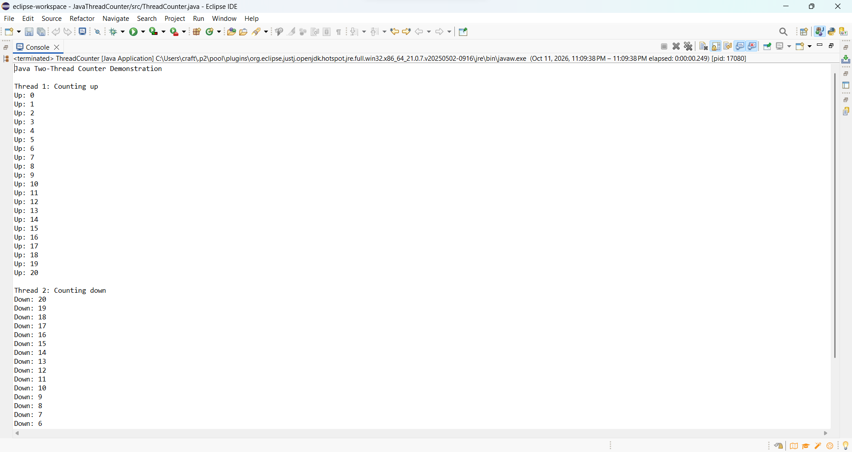
Figure 1. Java upward counter counting from 0 through 20.
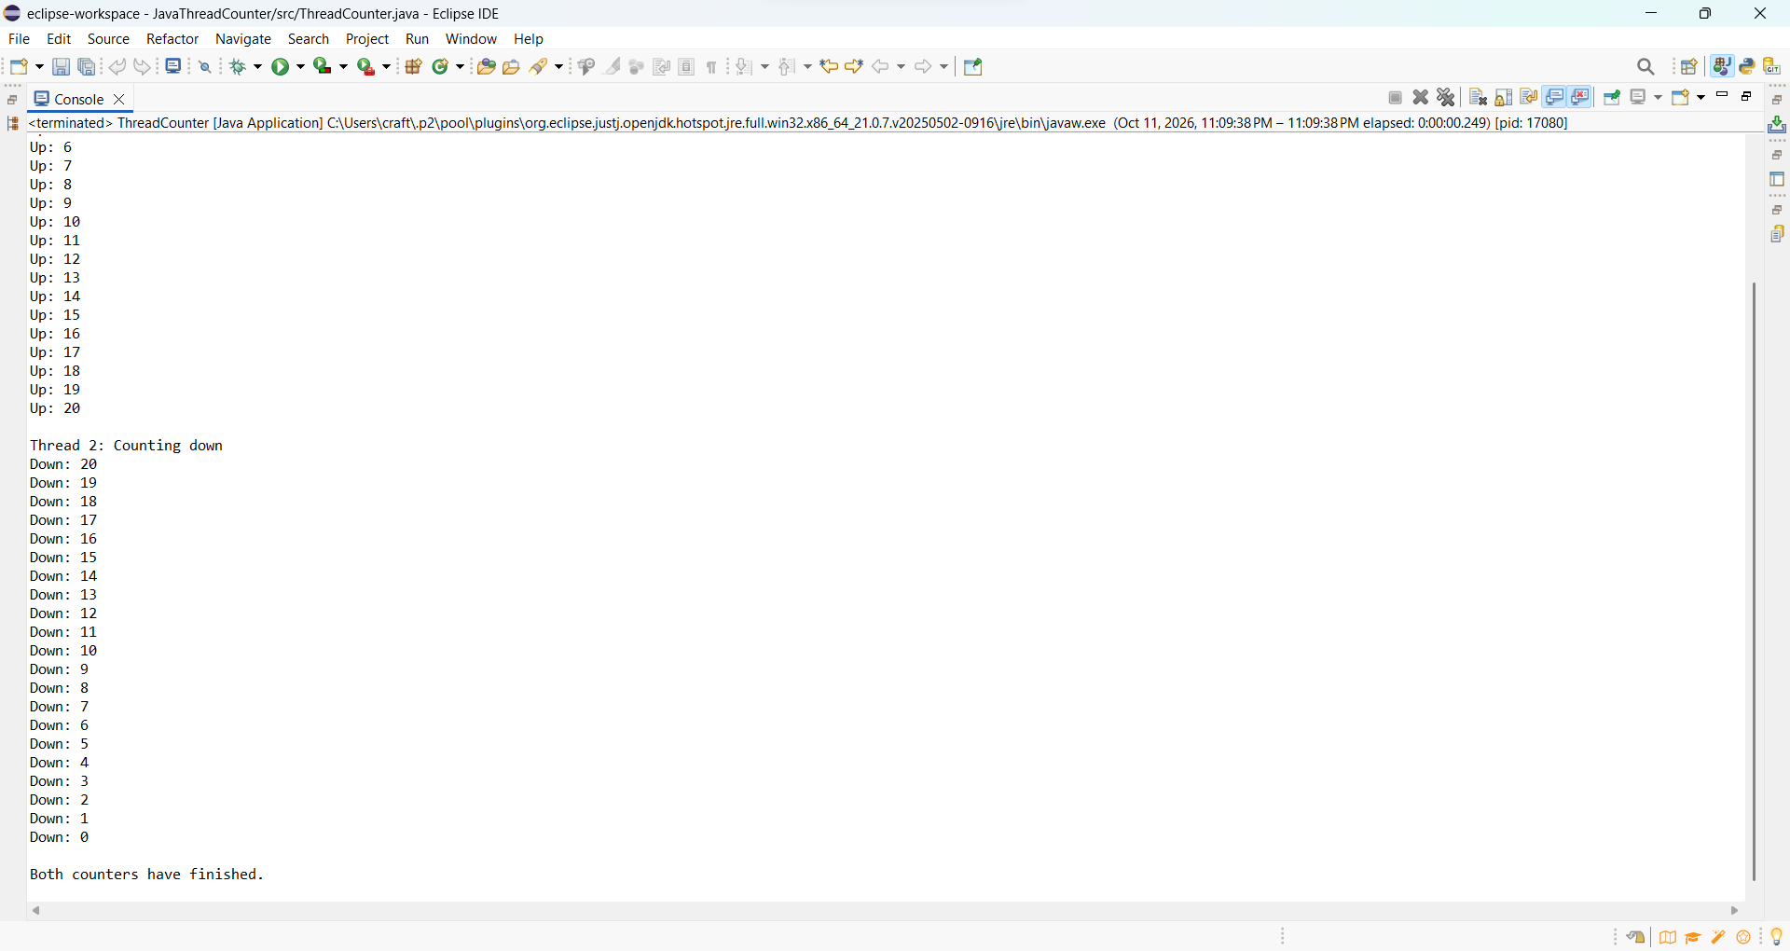
Figure 2. Transition to the downward counter, countdown to 0, and completion message.

Java Application Analysis
Performance Issues with Concurrency
For this application, the order of execution matters more than completing the arithmetic quickly. The upward worker must finish before the downward worker starts. I used start() to launch the upward thread and join() to wait for its completion. The same pattern controls the downward thread and ensures that the completion message appears after both counting tasks finish.
Although the program uses two worker threads, their counting tasks run sequentially. It therefore does not gain a speed advantage from performing the two loops in parallel. Creating threads and scheduling their execution adds overhead to a task that involves only 42 printed counter values. Console output also contributes to execution time. A direct call to each counting method could avoid thread-management overhead, but it would not demonstrate the thread behavior required by this project.
Each worker uses a local int variable, while COUNTER_LIMIT is a fixed constant. There is no shared counter being updated by both workers, so those values do not require locking. Waiting for the upward worker also prevents the two counting tasks from competing to print their output at the same time. Removing the first join() could allow the countdown to start before the upward count finishes.
The program catches InterruptedException because the main thread can be interrupted while waiting in join(). The catch block restores its interrupt status and reports the interruption instead of printing the normal completion message. This does not cancel a worker that has already started; that worker may continue until its loop finishes. In a larger application, cancellation would require an additional design for workers to detect and respond to interruption.
This run verified the required output order, but it did not measure execution time. I would need repeated tests under comparable conditions before claiming that this Java version is faster or slower than the C++ version. For this small demonstration, correct coordination is the main result.

Vulnerabilities Exhibited with Use of Strings
The Java counter uses fixed messages and combines labels such as “Up:” and “Down:” with each counter value. These operations produce String objects, whose contents cannot be changed after creation. Neither worker modifies a shared string, and the application accepts no external text input. This keeps the program’s exposure to string-related attacks limited.
Java manages string storage automatically, so this implementation does not copy characters into a manually sized buffer. It also checks indexes when methods such as charAt() access a string. An invalid index causes an exception instead of allowing ordinary Java code to read beyond the string’s bounds. These protections reduce memory-safety risks, although an unhandled exception can still interrupt a task.
Immutability does not make every use of a string secure. If I expanded the application to accept text, I would need to limit its length and validate it for its intended use. Extremely large input or repeated string construction could consume excessive memory. Passing untrusted text into a database query or operating-system command could also introduce injection vulnerabilities. Those operations would require parameterized queries or an appropriately designed command interface.
In the current loops, concatenation creates output strings for only 42 counter values, so the amount of work is small. A much larger version could create additional allocation pressure, depending on runtime optimizations. StringBuilder can help when assembling text through repeated modifications, but a shared StringBuilder would require coordination because it is mutable and is not thread-safe. For this program, local output expressions and fixed messages keep the string handling straightforward.

Security of the Data Types Exhibited
The counters use Java’s int type, which stores signed 32-bit whole numbers. This is more than enough for the required range of 0 through 20. Each loop initializes its local number variable before using it. After the upward loop prints 20, number becomes 21 and the loop ends. After the downward loop prints 0, number becomes -1 and its condition becomes false. These boundary values are safely within the type’s range.
COUNTER_LIMIT is declared private static final, so ordinary code cannot reassign it after initialization. Keeping the limit fixed also prevents external input from unexpectedly expanding the loops. The two number variables belong to separate method invocations, and neither worker accesses the other worker’s counter. As a result, this implementation does not need an atomic counter or a lock to protect those values. If I changed the design to share a writable counter, an expression such as number++ would require appropriate synchronization because it combines a read, calculation, and write.
Java’s defined integer behavior does not eliminate arithmetic risks. Ordinary int addition and subtraction wrap when a result exceeds the type’s range; they do not automatically report overflow. For example, changing the upper limit to Integer.MAX_VALUE would make the final increment wrap to a negative value, preventing this upward loop from terminating as intended. A version that accepts a configurable limit should validate the range and use a loop structure that handles its boundary safely. Methods such as Math.addExact() can detect overflow when checked arithmetic is needed.
The application also uses references to Thread and String objects. Java manages object memory and restricts ordinary code from performing raw pointer arithmetic, reducing opportunities for accidental memory corruption. However, references can still be null, and unused objects that remain reachable can consume memory. In this program, both Thread references are initialized before use, and the small, fixed workload limits resource consumption. These choices reduce risk without making the application immune to every programming error.

Comparison of the Java and C++ Implementations
My Java and C++ applications complete the same task: one worker counts from 0 through 20, and a second worker counts from 20 down to 0. Both versions keep the counters local to their counting functions and use a constant upper limit. These similarities make the comparison useful because the required behavior stays the same while the language features and execution environments differ. The successful runs demonstrate the expected output sequence, but they do not establish which implementation executes faster.

Thread Creation and Coordination
One difference is when creating a thread starts its work. In my C++ version, constructing std::thread with countUp begins the worker’s execution. The program then calls join() before constructing the downward worker. In Java, constructing a Thread object does not start its counting task. My program creates both Thread objects first, then calls start() and join() for the upward worker before starting the downward worker. Despite this difference, both implementations wait for the first counting task to finish before beginning the second.
The two join() operations serve the same basic purpose: they make the calling thread wait for the selected worker to finish. Oracle’s documentation describes Java’s join() as a way to wait for thread termination, while the C++ working draft specifies that join() blocks until the represented thread completes (Oracle, n.d.-b; ISO/IEC JTC1/SC22/WG21, n.d.-b). In these applications, the main thread coordinates the sequence while each worker performs its assigned loop.
Neither implementation runs the two counting loops in parallel. That is appropriate for the assignment because the downward count depends on completion of the upward count. Starting both workers immediately would allow their output to overlap and could violate the required order. I therefore consider synchronization the main accomplishment of these programs. The use of threads demonstrates coordination, but it does not divide this small counting workload into simultaneous tasks.

Performance and Resource Use
Both versions perform the same 42 counter-output operations and wait between their two counting tasks. Their arithmetic workload is small, so thread startup, scheduling, output formatting, and console activity all contribute to elapsed time. Neither design uses parallel counting to reduce the amount of work. For this particular task, adding more workers would increase coordination costs without removing the required dependency.
The output implementations differ. My C++ program inserts a label, integer, and newline into std::cout. The Java program uses string concatenation to combine the label and integer before calling println(). Java also runs within a Java Virtual Machine, while the C++ project produces a native executable. These differences affect the work involved in execution, but they do not provide enough evidence to declare a performance winner.
A useful measurement would separate total application startup from the time spent executing the counting tasks. It would also use repeated runs on the same computer, consistent output handling, and recorded compiler and runtime settings. Java warm-up and C++ optimization settings would need consideration. Because console output can obscure small computational differences, a separate test without printing could help investigate thread-management overhead, while the original application would remain the demonstration of required behavior.
I did not perform these timing tests, so my comparison is based on implementation choices and observed correctness. Both programs finished their counts in the required order. The strongest performance conclusion supported by these runs is that the sequential design limits opportunities for parallel speedup; a numerical ranking would require additional evidence.

Security Differences and Overall Assessment
Both current programs have limited exposure to external attacks because they accept no user input, use fixed counting limits, and keep their counters local. My C++ version does not manually allocate memory or copy text into writable character buffers. It would therefore be inaccurate to claim that this particular program contains a buffer overflow simply because it uses C++. The Java version likewise avoids shared mutable counter data, so its successful coordination comes from the design rather than an automatic guarantee that Java prevents concurrency errors.
Java offers stronger default protection against several memory-related mistakes. Oracle identifies automatic memory management, type safety, and array bounds checking as safeguards against common vulnerabilities (Oracle, 2025). These protections would become more significant if the application expanded to process external text or collections. C++ gives developers more direct control over memory, which also creates additional responsibilities for bounds and object lifetimes. Modern C++ techniques can reduce those risks, but they must be applied consistently.
Integer behavior provides another concrete distinction. Java defines int as a signed 32-bit type, while the width of C++ int depends on the implementation. Java integer overflow wraps without automatically raising an exception; C++ signed overflow produces undefined behavior (Oracle, n.d.-a; ISO/IEC JTC1/SC22/WG21, n.d.-a). Neither program approaches these boundaries with a limit of 20. However, allowing an unrestricted limit could make the final increment unsafe in both versions. Defined overflow behavior makes Java more predictable, but it does not make the resulting loop correct.
Error handling also differs in the submitted implementations. My Java program catches an interrupted join(), restores the main thread’s interrupt status, and reports the interruption. It does not cancel an already running worker. The C++ version joins its workers during normal execution but does not explicitly handle thread-related exceptions. This gives the Java version a clearer response to one waiting-related failure, although a more robust version of either application would need a deliberate failure-handling strategy.
I would consider Java the safer starting point for expanding this application because its runtime protections reduce opportunities for accidental memory corruption. This is an assessment of protective features, not evidence that my C++ program is insecure. Both versions still depend on sensible limits, correct synchronization, and careful handling of future input. My observed results establish that both implementations meet the counting requirement; they do not establish a performance winner or prove that either program is free of every possible defect.

References
ISO/IEC JTC1/SC22/WG21. (n.d.-a). Fundamental types [basic.fundamental]. In C++ working draft. https://eel.is/c++draft/basic.fundamental
ISO/IEC JTC1/SC22/WG21. (n.d.-b). Members [thread.thread.member]. In C++ working draft. https://eel.is/c++draft/thread.thread.member
Oracle. (n.d.-a). Chapter 4. Types, values, and variables. In The Java language specification, Java SE 21 edition. https://docs.oracle.com/javase/specs/jls/se21/html/jls-4.html
Oracle. (n.d.-b). Thread. In Java Platform, Standard Edition 21 API specification. https://docs.oracle.com/en/java/javase/21/docs/api/java.base/java/lang/Thread.html
Oracle. (2025). Secure coding guidelines for Java SE. https://www.oracle.com/java/technologies/javase/seccodeguide.html

